**Steps to deploy the project on the computer**

**1) Clone or Download the Project:**

Open the github link. The project is provided as a ZIP file, download and extract it.

**2) Install Prerequisites:**

Make sure you have the necessary tools installed, such as Visual Studio, .NET SDK, or any specific dependencies mentioned in the project documentation.

Also ensure to have Microsoft SQL Server and Microsoft Server Management Studio installed.

**3) Open the Project in Visual Studio:**

In the Visual Studio, open the .sln (solution) file with Visual Studio.

**4) Create the database**

Restore the test.bak file in the Microsoft SQL Server

OR

Open the SQL script file and execute the queries

**5) Build the Project:**

Build the project by right-clicking on the solution and selecting "Build" or pressing Ctrl + Shift + B.

**6) Run the Project:**

Set the startup project (right-click on the project and select "Set as StartUp Project").

Press F5 or click "Start Debugging" to run the project.

**6) Troubleshoot and Debug (if necessary):**

If there are issues, check the error messages in the output or console window. Use the debugger in Visual Studio to step through the code and identify any issues.

**Adding employee details**

Enter the details such as employee name, code, salary details in the respective controls and click Submit

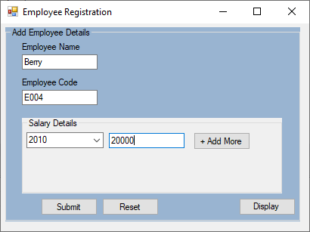 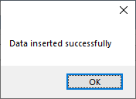

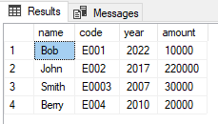

**View employee details**

Displaying all employee details

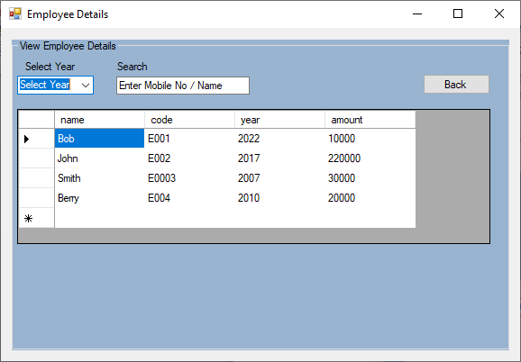

Search by year

Select a year from the year drop down

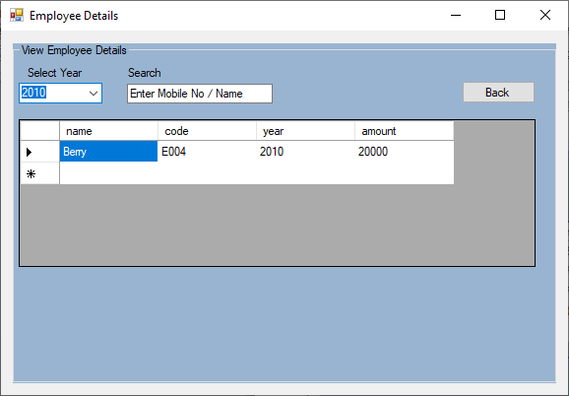

Search by name

Enter an employee name in the textbox

